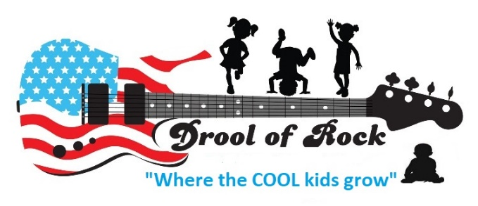 COVID-19 ADDENDUM
Please take a moment to read the policies and procedures Drool of Rock is required to execute by the Maryland State Department of Education due to the Covid-19 virus.

Drop Off and Pick Up Procedures:
- Parents and visitors are not permitted into our building. A teacher will greet you at the front door and safely escort your child to their classroom after washing their hands first.
- Parents must take their child’s temperature at the front door in front of a staff member before handing your child over for the day. The staff needs to see the temperature reading on the thermometer for documentation. PARENTS MUST BRING THEIR OWN THEMOMETER DAILY.
- Staff will ask a series of health screening questions at the front door before bringing your child into the building
- Please remain 6 feet apart from other families at drop off and wear a mask at all times.
Additional Preventative Measures
- Frequent handwashing (including upon entering the building, after recess, between transitions, before and after meal times, and bathroom breaks)
- Toilets are cleaned in between each use and so are outdoor toys
- Classroom toys and surfaces are bleached frequently every day
Children Now Require
- Multiple labeled face coverings cleaned daily – this is to prevent respiratory illness
- Hard plastic pencil case (the stackable kind) with their own crayons, markers, pencils and a pair of scissors to be left in the classroom at all times.
Tuition
- Should your child’s classroom need to temporarily close down due to a COVID scare, tuition will still be due and no refunds will be applied.
- Should your classroom close for more than three business days, a discount will be applied to your next payment. This pertains to only the classrooms effected by the closing.
- No activity fees will apply for infants or preschoolers at this time
- Teachers MAY NOT be called to babysit during COVID-19 closures. This is a rule with the Department of Health and Mental Hygiene. Teachers babysitting could be cause for closing more classrooms.

Sick Policy
- Sick policies are changing regularly with the Department of Health and Mental Hygiene.
- Updates are posted on the parent interest boards in the drop off area, written in Rockin’ Reports, and will be sent out via email.
- If your child is coughing at all, DO NOT SEND THEM TO SCHOOL WITHOUT A DOCTOR’S NOTE. This is the best way to prevent classroom shut downs. If a child is coughing in our care, we are required to send them home for testing and close the classroom until results come in.
Parent Communication
- We miss chatting with parents at pick up and drop off. But we are still here for you! Please email jenn@droolofrock.com with any concerns you have and I will forward it to our directors Amy or Dani as needed.
- Tons of information is posted at the sign in area and updated regularly. Take a moment to read it while you’re here.
- Rockin’ Reports go home weekly and are loaded with information about any changes in the program as well as a wrap up of the week and a peek into the next.
- Make sure you are receiving our texts and emails. If you are not receiving both of them, please let us know immediately.

I have read and understand the rules and regulations associated with the COVID-19 virus explained above.

Parent’s Name Signature Date

