Application Forms 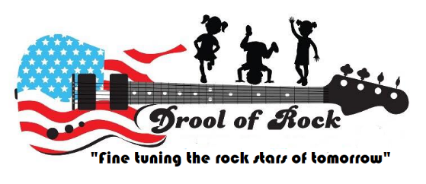
Image Release and Consent Form
At Drool of Rock we have a rockin’ fun time throughout our days. As a part of our unique learning experience, we often take pictures and videos that are used on our website, facebook page, and other promotions. This is an awesome way for parents to log on throughout the day and take a peek at the incredible things their children are doing. Please complete the form below to allow us to post pics of your little one. I have read, understand, and agree to this Release in favor of Drool of Rock, a Maryland corporation, who has three places of business (532 Cranbrook Road, Cockeysville, MD 21030, 10402 Ridgland Road, Cockeysville, MD 21030, and 10 Easter Court, suite C, Owings Mills, MD 21117). For valuable consideration, the receipt and sufficient of which is hereby acknowledged, I irrevocably consent to the following for myself and the children listed below: I agree to be the subject of one or more photographs or similar reproductive images of me and/or my likeness, captured in any manner. I agree to the unrestricted, perpetual, royalty-free us by Drool of Rock of such images for advertising and marketing purposes, and other purposes of trade, in and on any form of media, including still photographs, transparencies, motion pictures, television, video, the internet or other similar media. I agree that Drool of Rock in its sole discretion has the right to use my images without crediting me as the subject of the images. If Drool of Rock in its sole discretion decides to credit me as the subject of such images, however, I also agree to the unrestricted, perpetual, royalty-free use by Drool of Rock of my own name and other information I provide to Drool of Rock in conjunction with Drool of Rock’s use of my images.
I release Drool of Rock, it’s employees, directors, officers, agents, affiliates, successors and assigns from any and all claims of damages for libel, slander, invasion of privacy or any other claim whatsoever based on use of my images in and on any media. I also waive the right to inspect, restrict the use of, or otherwise approve the use of my images in and on any media.
I agree that this Release shall be governed by and interpreted in accordance with the laws of the State of Maryland (without regard to its principles of conflicts of law), and that I submit to the exclusive jurisdiction of the state and/or federal courts located within the State of Maryland for any claim related to this Release, the Image or the Media. This Release shall be binding upon and inure to the benefit of me, my heirs, legal representatives, and assigns.
IN WITNESS WHEREOF, I have executed this Release on the day and the year set forth below.
I agree with the preceding image release and I allow my child to be photographed
I DO NOT agree with the preceding image release and I DO NOT allow my child to be photographed
Signature of Parent/Guardian____________________________________________________Date_____________________
Signature of Parent/Guardian____________________________________________________Date_____________________
Child’s Name________________________________________________Gender______________D.O.B__________________
Drool of Rock also has private group chats specific to each classroom. The members of each chat include only the family members of the children enrolled in that classroom and the teachers providing care. Please check off the box below that reflects your personal preference regarding private group chat posts for your classroom.
YES! My child can be posted in the private group chat via the app Group Me.
NO! My child may not appear in the classroom group chat via the app Group Me.

