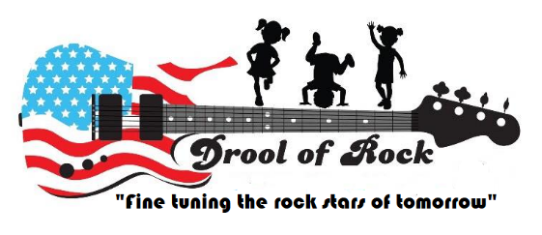

Parent Agreement

By initialing on the lines below, I acknowledge the rules, regulations and fees that have been set forth in my tour packet.

____________ I agree to the late fee policy for late pick-ups.
____________ I agree to the late fee policy for tuition payments.
____________ I agree to the Diaper / Wipe fee
____________ I understand that as a preschool parent, I can no longer send in outside beverages
____________ I understand that tuition is due regardless of attendance, closings and/or holidays.
_____________ I agree to the Sick Policy and Procedures for pickup and return to school
_____________I agree to the Discipline Policy set forth in this packet
_____________ I agree to give Drool of Rock two week’s written notice before withdrawing my child from the program. I understand that my card on file will be charged for the last two weeks of care regardless of attendance.
_____________I acknowledge that there is a Termination Policy that is required to be signed and submitted for my child’s file.

By signing below, I agree to the rules and regulations set forth and explained in my tour packet.

Parent/Guardian Name Signature Date

Parent/Guardian Name Signature Date

