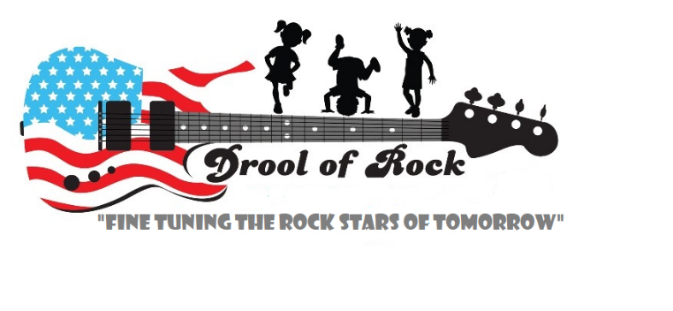
Application Forms

Emergency Medical
Consent Form

Drool of Rock and it’s instructors have permission to obtain emergency medical treatment for my child
______________________________________ when I can’t be reached or if a delay in reaching my child would be dangerous for him/her.

Mother/Guardian’s Name______________________________________________________________
Home Phone_________________Work Phone____________________ Cell Phone________________
Email Address________________________________________________________________________

Father/Guardian’s Name______________________________________________________________
Home Phone_________________Work Phone____________________ Cell Phone________________
Email Address________________________________________________________________________

Insurance Provider____________________________________________________________________
Child’s Medical Record Number_________________________________________________________
Preferred Hospital / Center_____________________________________________________________
My Child’s Medications________________________________________________________________
My Child’s Allergies___________________________________________________________________

By checking this box, I understand that I assume all financial responsibility for any treatment or inuries sustained by my child while he/she is in child care at Drool of Rock.

Signature of Parent/Guardian ________________________________________ Date________________
Signature of Parent/Guardian_________________________________________Date________________

