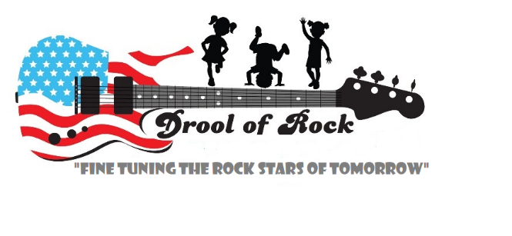
Application Forms

Safe Pick-Up List

I __________________ authorize the following people listed below to pick up my child from Drool of Rock childcare center.

Name Phone Relation to Child

Child's Name_____________________________ Birthday ________________
Name of Parent/Guardian__________________________________________
Signature of Parent/Guardian_________________________ Date__________

