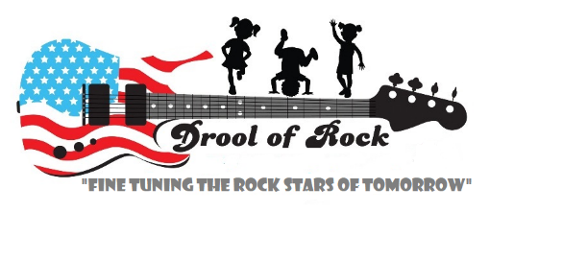
My Care Plan
Ages 6 Weeks – 23 Months

Child’s Name: _________________________________________ Date: ____________________
Updated: __________________ Updated: __________________ Updated: ________________

ARRIVAL
What time will you usually arrive at the center?____________________
What will help you and your child say good-bye to each other?

DIAPERING & TOILETING
What type of diapers do you have?_______________________________
How often do you change your child’s diaper? When does your child typically need a diaper change?

Are there any special instructions for diaper changes?

SLEEPING
How will we know that your child is tired and needs to sleep?

When does your child usually sleep? For how long does he or she usually sleep?

What helps your child fall to sleep?

We put babies on their backs. Is your baby used to sleeping on his or her back? Y / N
How does your child wake up? Quickly / Slowly
When does your child prefer to be removed from the crib? Immediately / After a few minutes

EATING
Babies:
Method: Breastfeeding / Bottle feeding
If breastfeeding,
Will you come to the center to breastfeed? Y / N
If so, what time? _____________________
If not, will you send expressed breast milk? ___________________
If bottle feeding,
What kind of formula do you use? ________________________________________________
How do you prepare the bottles? ________________________________________________
How much does your baby typically drink at one time? ______________________________
Does your baby drink water during the day? Y / N
If so, what do they prefer to drink out of? Bottles / Sippy cups
When and how much? ______________________________________
Is your baby eating solid foods? Y / N
If so, which ones? ____________________________________________________________
When? _____________________________________________________________________
How do you prepare your baby’s solid foods? ______________________________________
How much does your baby eat at one time? ________________________________________
What position does your baby prefer to be in when fed? __________________________________
Does your baby eat finger foods? Y / N
If so, which ones?

All Children:
What are some of your child’s favorite foods?

What foods does your child dislike?

Is your child sensitive or allergic to any foods? Y / N If yes, please list them:

Are there any foods that you don’t want your child to eat?

DRESSING
Is there anything special that we should know about dressing and undressing your child?

AWAKE TIME
How does your baby like to be held? What position does your baby prefer when they wake up?
In what language do you speak and sing with your child at home?

What language does your child use when talking and singing with family members?

What does your child like to do when awake?

How do you play with your child?

DEPARTURE
What time will you typically come to pick your child up? ___________________
What will help you and your child say hello to each other at the end of the day?

