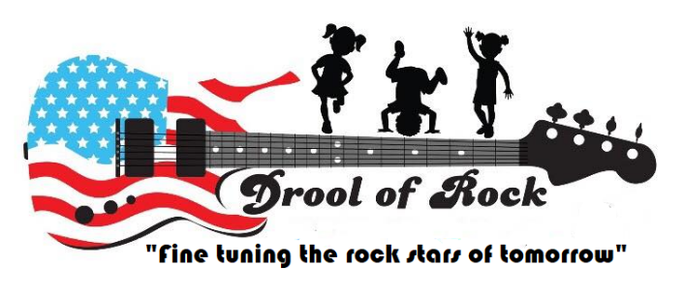
Termination of Care Policy

Termination of Care is never a decision that Drool of Rock takes lightly. We do our very best to work with the families and children within our program. In order to ensure the safety and well-being of everyone at Drool of Rock, there are a number of situations, should they occur, that will result in termination of care. Please read through the following to have a better understanding of our position on behaviors we will not foster within our program.

Continually Late Tuition Payments
Tuition is due weekly, biweekly or monthly as chosen by each family on their credit card authorization form. Failure to pay on time will result in a $25 late fee. Repeated late payments will result in a written warning before termination of care.
Inability to Meet Physical or Developmental Needs
Drool of Rock makes strides to accommodate children with both physical and developmental special needs. However, sometimes it is impossible to meet the needs of a particular child with the ratios set forth by the Maryland State Department of Education. We will make all reasonable efforts to accommodate him or her. If the child requires more attention than our staff can provide, we will document the issues, attempt to work through them with parents, and provide a written warning before terminating care.
Disruptive Behavior
We are armed with tools to develop children’s emotional and social skills so we can mitigate and change disruptive behaviors. Should behaviors not subside after documentation and communication with parents, we will provide a warning before terminating care.
Disruptive Behaviors can also refer to situations with parents. Causing a scene or aggressively addressing your own child, a staff member, another parent or any other children in our program will result in immediate termination of care at the discretion of Drool of Rock.
Failure to Provide Required Materials for Child
The list of materials your child needs daily is provided in your Tour Packet / Parent Agreement. Should those items not be provided daily, you will receive a written warning before we terminate care.
This includes but is not limited to bedding, diapers, wipes, seasonally appropriate clean clothing, food, and all paperwork required for your file.

Repeated Late Pickups
The Late Pickup policy is also explained in the Tour Packet / Parent Agreement. However, repeated late pickups will result in a written warning before termination of care.
Violent Behavior
If violent behavior from a parent is witnessed, Drool of Rock will immediately end the relationship and report at required.
If the violent behavior is from a child, we will work with the child and family to correct the behavior. Sometimes this is successful, other times it is not. Drool of Rock reserves the right to terminate care for the safety of everyone in our program should the violent behaviors continue.
Abuse of the Staff
Abuse is not always related to violence, it can be verbal as well. Our staff is an important asset and should be respected and treated as such. If abuse is reported by a staff member, Drool of Rock will investigate and reserves the right to terminate care.
Violation of Sick Policy
The sick policy is set forth by the Maryland State Department of Education and will be strictly enforced. Sending your child to school sick repeatedly, and failure to pickup when notified within the allotted hour will result in a written warning and possible termination of care.

By signing below, I agree that I have read and understand the Termination Policy set froth by Drool of Rock childcare center.

Parent Name Signature Date

Parent Name Signature Date

