
Thanks so much for your interest in our program, and for taking the time to tour with us today.

Cockeysville: 10402 Ridgland Road Phone: 410-628-7625(ROCK) Fax: 410-628-7626
Owings Mills: 10 Easter Court Phone: 410-363-7625(ROCK) Fax: 410-363-4698
DIRECTORS
Cockeysville: Hailee Hunter - hailee@droolofrock.com
Owings Mills: Erica Sommersdorf – erica@droolofrock.com
WARNING: You may leave Drool of Rock with the “Drool of Rock Fever”.
Symptoms may include, but are not limited to:
- Crazy responses from children, such as kicking and screaming, because they’re not ready to leave the building.
- The feeling of regression in age as adults, and the nagging wish to be younger so you too can spend your days here.
- Crazy, intense dreams about your child on our stage, ROCKIN’ their BIG world.
- Overwhelming thoughts and feeling that your child is far cooler than everyone else’s you know.
- The satisfaction of knowing that your child’s confidence and happiness is soaring.
Treatment:
Enroll today and know that your child will live, love, learn and ROCK!
We aren’t just a childcare center… we are an unforgettable experience.

For more information, visit us on the web at www.droolofrock.com
Or like us on Facebook at www.facebook.com/droolofrock
TUITION:

 | INFANT | 2’s | 3/4’s
DAILY | $134.00 | $112.00 | $99.00
T/TH | $269.00 | $226.80 | $199.00
MWF | $406.35 | $339.15 | $299.00
Full Time | $539.00 | $449.00 | $399.00
T/TH Monthly | $1,165.66 | $982.80 | $862.33
MWF Monthly | $1,760.85 | $1,469.65 | $1,295.66
Full Time Monthly | $2,335.66 | $1,945.66 | $1,729.00
DROP IN | $138.00 | $114.00 | $103.00

Children ages 2-5 will have an activity fee processed on the first of the month:
Part Time = $12.50 / month Full Time = $25 / month
Drool of Rock ONLY accepts Credit Card Payments. A credit card authorization form is required upon enrollment. Cards on file will be debited weekly, biweekly or monthly.
A $25 late fee will be applied for past due tuition payments.
TUITION IS DUE REGARDLESS OF ATTENDANCE. This applies to sick days, personal days, vacations, holidays, inclement weather closings and breaks of any kind.
TWO WEEK’S NOTICE: Drool of Rock requires a written two week notice before withdrawing your child from our program. Tuition will be two for two weeks after the dated letter or email.
Access to your account information can be found at www.myprocare.com
Please use your email on file to log in and create a password.
Tuition increases in January every year.

HOURS & LATE PICKUPS:
Monday thru Friday 7:00 am – 6:00 pm
We understand that life happens and there can be occasional parents picking up after business hours. Please note the following times and fees associated with pickups occurring after 6:00pm.
6:00 – 6:30 = $1/ minute
6:31 – 6:45 = $15 / minute
Pickups after 6:45 could result in enrollment termination
Frequent late pickups can also result in enrollment termination.
Late pickups will be documented by closing staff and the person picking up is responsible for the fees involved. Payments must be made within 48 hours, preferably in cash, and given directly to the staff member caring for your child after hours, or to management in an envelope labeled with the staff members name or the date the late pickup occurred so it can be distributed to the appropriate staff members.
If the late fee is not paid within 48 hours, there will be a $10 fee added to the total.
Refusal to pay a late fee can also lead to enrollment termination.
We love your little ones so very much. As management, we also love our teachers and need to respect and compensate for any of the staff’s personal and family time that is affected by late pickups.

OUR CURRICULUM:
Toddlers – In this class we will begin introducing circle time routines and songs. Daily art projects will also be infused into their schedule.
Preschoolers – Schedule includes circle time, weekly themes, daily writing exercises and art projects.
K-Prep – Our days are packed with learning games, small group work, sight words, math fun, science and art.
Children will be assessed three times a year (January, June and September).
Conference requests can be made through our Telegram app. We offer conferences once a year on June 15th, during the time of assessments. We offer conferences upon request throughout the entire year as well. We notify parents via Telegram and will have sign-up sheets posted at the front desk.
Curriculum is posted for the coming week on Fridays in the Group Chats for parent review.
Inclusion Policy:
Our program accepts all children including those with special needs and special health care needs. We will make reasonable accommodations for your child as our program structure allows. If your child has an instructional support specialist or therapist, we will allow them in our program and collaborate as needed. We encourage parents to let us know of any needs.

PARENT / TEACHER COMMUNICATION:
At the time of enrollment, parents will be added to a classroom chat via the app Telegram. The Telegram app will need to be downloaded on both parent’s devices. We will post curriculum, pictures, videos, and any other important news and updates specific to your child’s classroom. You will have direct communication with your child’s teacher throughout the day, however, please keep the group chat comments generalized and not specific to your child. If you need to message the teacher privately regarding your little one, there is an option for that as well.
Don’t hesitate to call the main line of the center if you have any questions throughout the day regarding your child.
The turn-around time for responses from teachers may vary. Please understand that our teachers cannot focus on the children in their care if they are also constantly on their phones. Your teacher will likely message you more in your child’s first few days, just to help parents feel relaxed, but expect communication to decrease a bit once your child is settled in.
In order to provide you with as much detail as possible about your child’s day, the teachers will complete daily sheets and place them in your cubby at the end of every day.
Infant Daily Sheet 2’s & 3’s Daily Sheet 4’s & 5’s Daily Sheet
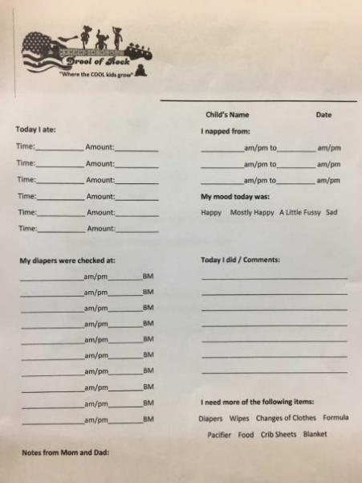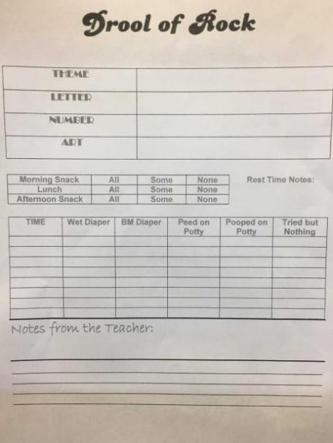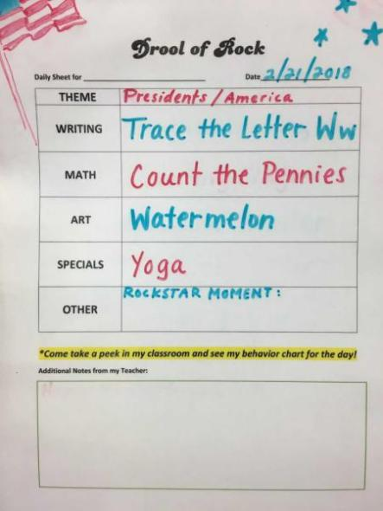
Teachers will post their curriculum on Fridays for the coming week for parents to review.

MUSIC AND SPECIALS:
Our one-of-a kind music program is what separates us from any other Early Learning Center out there.
We have partnered up with the Lutherville Rock School to bring you the absolute coolest music teachers in town. Our classes will change throughout the year and include ukulele lessons, piano basics, drum lessons, into to music, dance, chorus and theater.

STAFF AND RATIOS:
All of the teachers at Drool of Rock have been approved by the MSDE and participate in the Continuing Education program to stay current with age- appropriate activities, safety, education and care. Full background checks are performed before entering the building.
We follow the MSDE guidelines for classroom ratios.
Infant Classrooms – 2 teachers and (up to) 6 infants
Toddler Classrooms – 3 teachers and (up to) 9 toddlers
2 year old Classrooms – 2 teachers and (up to) 12 children
3 and 4 year old Classrooms – 2 teachers and (up to) 20 children
5 year old K-Prep – 1 teacher and 10 children

MEALS:
Infants and Toddlers:
All food served is brought from home.
Please supply all bottles necessary for the day and send them prepared and ready to heat.
No Glass Bottles.
Preschoolers:
You pack lunch.
We provide breakfast snack and afternoon snack.
No Glass Containers.
ABSOLUTLEY NO DRINKS ARE PERMITTED IN THE BUILDING. We offer milk and water with every meal and the children have access to water coolers throughout the entire day and water breaks are incorporated into their daily routine.
We have microwaves in every classroom to heat up any food sent from home that requires warming, and refrigerators in every room to store lunches.
REST TIME:
Infants
Detailed care plans are provided by parents. Our teachers will do their very best to see that your child follows the sleep schedule you have provided.
Preschoolers
Each child is provided a cot.
The child must have something to lay on and to cover up with. You may send a sheet and a blanket, two blankets, or what we encourage which is the sleep sack. (They are mini sleeping bags with built in pillows)
Two blankets OR one sheet and one blanket must be provided. Pillows are a nice touch too.
Rest time stuff is sent home on Friday for washing and must be returned when your child returns the following week.
Rest time is from 1-3.
The children are not required to sleep but they are encouraged to rest and recharge without disturbing friends around them.
Often audio books, meditation music and lullabies are played on the sound systems in each room.
K-Prep
Quiet time is from 2-3pm

OUTDOOR PLAY:
Weather permitting, our children go outside for recess twice a day. Please make sure to properly dress your child for the weather.
For children’s safety, we require closed toe shoes for recess.
ENROLLMENT:
ALL paperwork must be completed and submitted before your child’s first day in our care.
Enrollment can be done by phone by calling the center and asking to speak to a director
Please visit our website at www.droolofrock.com/enrollment to print and complete all necessary forms for enrollment.
In addition, please complete the forms in the back of this packet and return when you complete your registration.
WHAT YOUR CHILD WILL NEED:
=[ | Preschool and K-Prep
Lightweight breathable blankets | Lunch Daily with an Ice Pack
At least 2 crib sheets | Two Blankets or 1 Blanket and 1 Sheet
Spare clothing (5 outfits, seasonally appropriate) | Space Clothing – 1-2 outfits
Large, shallow bin to slide under crib | Diaper and Wipe Supply if needed
Diapers, Wipes and Diaper Cream Supply
Pacifiers and Bottles
Formula or Breastmilk and Lunch
Spit up clothes

PLEASE CLEARLY LABEL EVERYTHING!
PLEASE DO NOT BRING IN TOYS FROM HOME.
PLEASE NOTE: Failure to supply diapers and/or wipes will result in a fee.
Diaper fee - $2/diaper
Wipe fee - $2 / changing
If you do not respond to the request for more diapers and wipes for your child, we can refuse care until you provide us with the proper materials necessary to provide your child with the proper care.
YOUR CHILD ALSO NEEDS ALL THE REQUIRED PAPERWORK ON FILE BEFORE WE CAN PROVIDE CARE.

POTTY TRAINING:
Potty training is something we encourage for each child and are ready to rock it out when they are. We have a potty-training policy that we give to our two-year-old parents to review and complete so that we can all work together.

DISCIPLINE POLICY:
We use a positive approach to discipline such as:
- Using positive reinforcement for appropriate behavior choices
- Redirecting the child
- Using patience, love and understanding
- Setting clearly defined limits
- Talking about acceptable ways of handling situations as they arise
- Sticker charts and Prize Bins

On occasion, children get truly frustrated or upset and in turn have difficulty following classroom rules. In this case, we simply ask them to go to the “Calm Down Clouds”. There is a safe, fluffy area in every classroom, that we refer to as our clouds. There are books, activity boards and manipulatives there that the children can choose to work with, rather than the group. Teachers will meet a child in the clouds and help them work through what is bothering them in a one-on-one setting. Please see our Discipline Policy Form in our enrollment packet for more info.
If multiple incident reports or behavior charts come home for your child, a team meeting will be required between the staff and parents. Should the behaviors in question continue, Drool of Rock reserves the right to remove the child from our program.
Biting can be a frustrating but a common struggle primarily in toddlers. If your child goes through this phase, we will do everything in our power to redirect them and correct the behavior. On occasion, a child may require a “shadow” for certain hours of the day to intercept biting opportunities. This could result in a slight raise in your tuition to provide these one-on-one services. This will be discussed in advance with your family before proceeding. If biting cannot be eliminated, we may have to terminate care for your child.

SICK POLICY:
Please take a moment to review our sick policy.
If your child becomes ill in our care, we will call the people on the Emergency Card in the order in which they are listed. You child will be separated from the group, snuggled and loved until pick up.
We require that someone comes within the hour.
Sent home sick forms will be signed upon pickup acknowledging the return policy based on symptoms.

DROP OFF:
We understand that separation between parent and child can create some anxieties, and sometimes tears. Please know that your child will be comforted by his or her teachers. In order for our teachers to provide support to a child struggling with drop off, we need for parents to exit quickly. The longer the goodbye, the longer the cry.

TERMINATION POLICY:
Drool of Rock reserves the right to terminate care for a number of reasons. Please read the Termination Policy, print, sign by both parents and submit for your child’s completed file.

SCHOOL CLOSINGS AND DELAYS:
We do our very best to stay open as much as possible for our families.
Tuition is due regardless of attendance and closings.
We make our own inclement weather call via telegram.
FAILURE TO PICK UP WITHIN THE ALLOTTED HOUR FOR ANY TYPE OF CLOSURE/EARLY DISSMISSAL WILL RESULT IN A TERMINATION WARNING AS WELL AS A LATE FEE EXPLAINED IN THE LATE FEE POLICY.
Upon enrollment we will sign you up for the proper Telegram Classroom Chats. If decide to close, open late or have an early dismissal, families will be alerted via Telegram.
We are closed for the following holidays:
- New Year’s Day
- Spring Break (Good Friday through the Monday following Easter Sunday)
- Memorial Day
- July 4th
- Labor Day
- Thanksgiving and the Friday that follows
- December 3rd we close early at 3pm
- December 24th through December 26th
- New Year’s Eve we close early at 1pm
PLEASE NOTE: If a holiday falls on Sunday, we may close the following Monday.

THANKS FOR TAKING THE TIME TO GET TO KNOW US AND CONSIDERING OUR PROGRAM FOR YOUR LITTLE ONE(s). HOPE TO SEE YOU VERY SOON!
Live Peacefully.
Love Equally.
Learn Wondrously.
Rock and Roll.
Enrollment Checklist
Please make sure all of the following requirements are checked off and submitted with your enrollment paperwork before your child’s first day.

________Child Intro Form (2-5 years) OR Care Plan (6 weeks – 23 months)
Please complete this form to the best of your ability so your teacher can get to know your child before their first day
_________Emergency Form
This form MUST include AT LEAST ONE person that can be called in the event of an emergency if the parents cannot be reached. If you do not have family to list, we suggest listing a coworker that could easily get a hold of you if we cannot.
Please also include the child’s physician or source of health care required at the bottom of page one.
_________Health Inventory Part One
This part is to be filled out by the parent and then submitted to the pediatrician to complete the second part.
_________Health Inventory Part Two
The second part of the Health Inventory MUST be completed by THE PEDIATRICIAN.
*If your child has any allergies or food restrictions, please make this clear on the Health Inventory as well as verbally, upon enrolling your child. If medication, albuterol, or an epi pen are required, we need an allergy action plan and medication administration form on file along with the required treatments at all times.
_________Immunization Records
Up to date immunizations must be on file before your child’s first day, and kept up to date. Parents are required to send updated immunizations as they occur during wellness visits.
_________Lead Test
Must be completed and signed by a physician at 12 months and 24 months for all children in our care.
*MEDICAL PAPERWORK CAN BE FAXED DIRECTLY TO THE CENTER. FAX NUMBERS ARE LOCATED AT THE TOP OF THIS PACKET.
_________Image Release
This form authorizes Drool of Rock to post photos of your child on our Facebook page, Instagram page, and any marketing materials. Drool of Rock also has private group chats for each classroom that only include the parents of children in our care and the teachers working with your child.
*Please specify If you would prefer that your child stay off of social media and marketing materials but are okay with them being posted in our private group chat. This section is at the very bottom of the image release form
_________ Emergency Medical Consent __________ Child Enrollment Record
_________ Discipline Policy __________ Termination Policy
_________ Parent Agreement __________ Safe Pickup List
_________ Credit Card Authorization __________ Toilet Training Policy (ages 2+)
_________ Late Fee Policy __________ Allergy Action Plan (if needed)
_________ Medication Administration (if needed at school) __________ Allergy & Anaphylaxis Form (if needed)

